LIST KONTEN WEB BMTH

**PALLET WARNA :**

Primmary Color : #9A0F0F / Box Shadow : #AD1C1C

Seccondary Color : #FFF / Box Shadow : #EBD6D6

Background Color : #151313

Warna List Kota : #765050

Background Layout Payment Gateway : #FFF visibility 73.33%

Background Layout Display Ticket : #201717

Bg Pop Up : Gradient linear(#2e2e2e to right #1a1515)

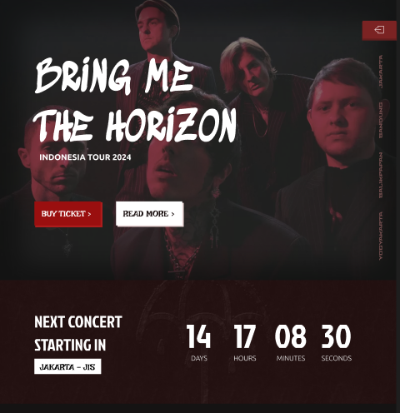

**Artikel :**

**Judul : BRING ME THE HORIZON** ( f-size : 170px, f-family : Sedgwick AD)

**INDONESIA TOUR 2024 (**f-size: 30px,f-family: Ubuntu Bold)

**BUY TICKET & READ MORE** (f-size :30px, f-family : Irish Groover, width:240px, height:87px**)**

**List kota** (f-family: stalinist one, f-size : 15px)

**NEXT CONTENT STARTING IN** (f-size : 60px, f-family: Jockey One)

**JAKARTA JIS** (f-size:30px,f-family:Irish Groover, height : 56px, width : 242px color black, bg-white)

**List sosmed :** bg-white, height&width : 90px, border-radius : 20px 0 20px 0)

**Hitungan mundur** (Jockey One, 120px)

**waktu hitungan mundur** (ubuntu light, 25px **)**

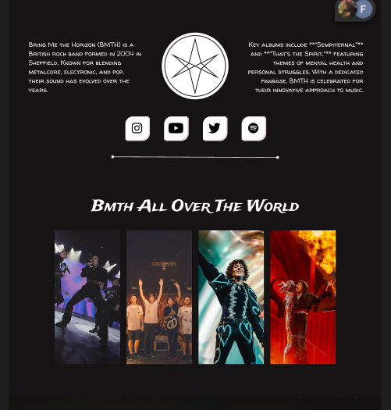

**Deskripsi About bagian kiri :** Bring Me the Horizon (BMTH) is a British rock band formed in 2004 in Sheffield. Known for blending metalcore, electronic, and pop, their sound has evolved over the years.(walter turncoat, 25px)

**Deskripsi About Bagian Kanan** : Key albums include **"Sempiternal"** and **"That's the Spirit,"** featuring themes of mental health and personal struggles. With a dedicated fanbase, BMTH is celebrated for their innovative approach to music. (walter turncoat, 25px)

**Title Album Section :** Bmth All Over The World(trade winds, 60px)

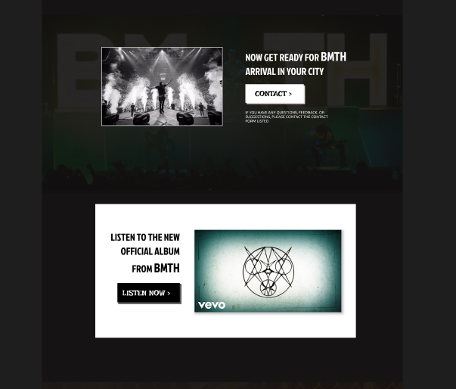

**BAWAHNYA ALBUM SECTION :** NOW GET READY FOR BMTH ARRIVAL IN YOUR CITY (Jockey One, 40px)

**BAWAHNYA BUTTON CONTACT** : IF YOU HAVE ANY QUESTIONS, FEEDBACK, OR SUGGESTIONS, PLEASE CONTACT THE CONTACT FORM LISTED (ubuntu light, 15px)

**DI KIRINYA ALBUM** **YANG ADA THUMBNAILNYA** : LISTEN TO THE NEW OFFICIAL ALBUM FROM BMTH (jockey one, 40px 50px)

LISTEN NOW ( IRISH GROOVER, HEIGHT 77PX, WIDTH 249PX, BG BLACK, COLOR WHITE)

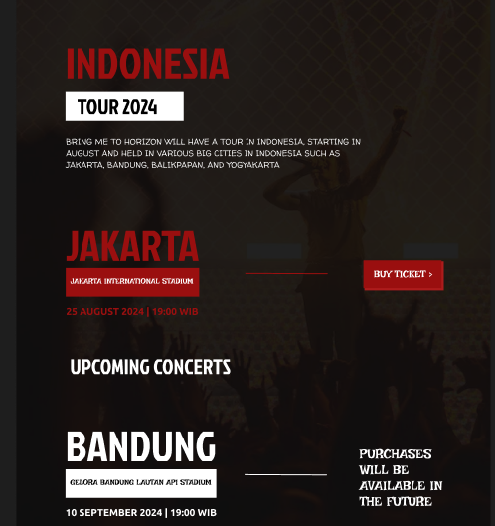

INDONESIA ( JOCKEY ONE, 130PX, PRIMARY COLOR)

**TOUR 2024 (height : 88px, width : 359px, bg-white, color-black)**

**DIBAWAHNYA TOUR 2024 (yang di dalam border kuning)** : BRING ME TO HORIZON WILL HAVE A TOUR IN INDONESIA, STARTING IN AUGUST AND HELD IN VARIOUS BIG CITIES IN INDONESIA SUCH AS JAKARTA, BANDUNG, BALIKPAPAN, AND YOGYAKARTA

**TITLE TOUR :** JAKARTA (color : primary, jockey one, 130px)

**Lokasi Tour :** JAKARTA INTERNATIONAL STADIUM (color : white, irish

Bg-primary, height: 87px, width: 405px, groover, 23px)

**Button buy ticket :** BUY TICKET > ( irish groover, 30px, white)

**Waktu concert :** 1 OKTOBER | 2024 | 19:00 WIB (ubuntu bold, 30px, primary color)

**Title upcoming :** UPCOMING CONCERT (jockey one, 64px, white)

**KOTA KONSER PERTAMA:** BANDUNG ( jockey one, 130px, white)

**TEMPAT KONSER PERTAMA:** GELORA BANDUNG LAUTAN API STADIUM (irish groover, black, bg-white, height : 87px, width: 458px)

**WAKTU KONSER PERTAMA :** 10 SEPTEMBER 2024 | 19:00 WIB (ubuntu bold, white, 30px)

PURCHASES WILL BE AVAILABLE IN THE FUTURE (IRISH GROOVER, SIZE : 40PX)

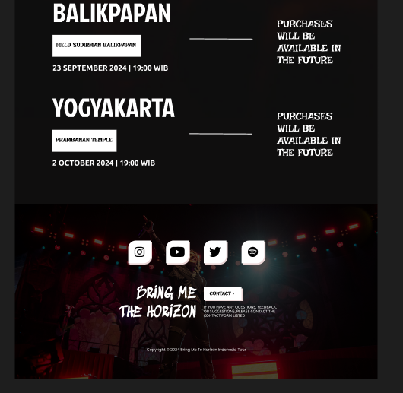

**BALIKPAPAN** (JOCKEY ONE, 105PX, WHITE)

**FIELD SUDIRMAN BALIKPAPAN** (HEIGHT : 87PX, WIDTH : 350PX, COLOR BLACK, BG WHITE)

**23 SEPTEMBER 2024 | 19:00 WIB (**UBUNTU BOLD, 30PX**)**

**YOGYAKARTA (**JOCKEY ONE, 105px, white **)**

**PRAMBANAN TEMPLE (**IRISH GROOVER, SIZE 23PX, HEIGHT : 87px, Height : 255px, bg-white, color black**)**

**2 OCTOBER 2024 | 19:00 WIB (**ubuntu bold, 30px)

Judul di footer : **BRING ME THE HORIZON (**sedgwick AD, 60px**)**

Text footer : **Copyright © 2024 Bring Me To Horizon Indonesia Tour (**ubuntu 15px**)**

TICKET PAGES

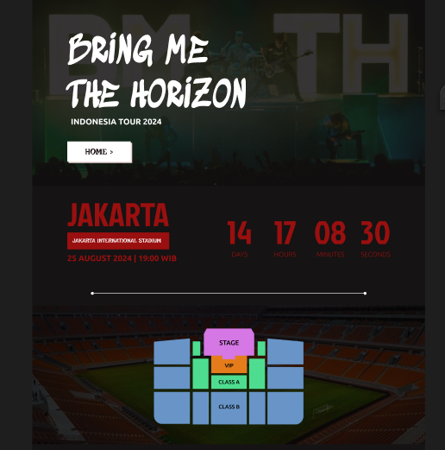

**BRING ME THE HORIZON (**size 130px, sedgwick ad**)**

**INDONESIA TOUR 2024** (UBUNTU BOLD, 30PX)

**HOME > : (**irish groover, size : 30px, height : 74px, width:233px**)**

**JAKARTA (**jockey one, primary color, 120px)

**JAKARTA INTERNATIONAL STADIUM : (irish groover 20px, height: 62px, widht : 374px)**

**25 AUGUST 2024 | 19 : 00 WIB : ( ubuntu bold 30px)**

**COUNTDOWN : (jockey one 120px )**

**DAYS,HOURS,MINUTES,SECOND : ( ubuntu light 25px)**

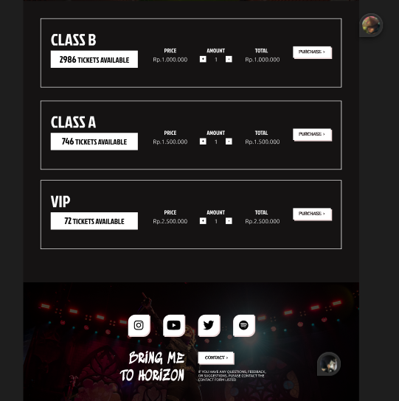

**RECTANGLE : (w=1291px h=296px border 2px solid #ffffff)**

**CLASS A, B , VIP : ( jockey one 70px)**

**TICKET AVAILABLE : ( jockey one 32px (angka 40px) h=373px w=74px)**

**Price amount total : ( jockey one 25px)**

**Price number : ( ubuntu light 25px )**

**Plus-min button : (w=27px h=27px jockey one 25px )**

**Purchase button : (w=162px h=49px box-shadow= 5 5 0 0 #EBD6D6 )**

**Purchase : ( irish grover 20px )**

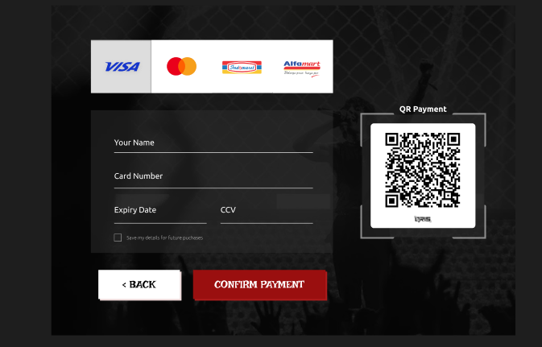

**YOUR NAME (UBUNTU REGULAR 25PX)**

**Button back(w=253px, h=90px, irish groover fsize = 32px,bg-white,color black)**

**Confirm payment (w=411px,h=90px,fsize=32px, bg primary,color white)**

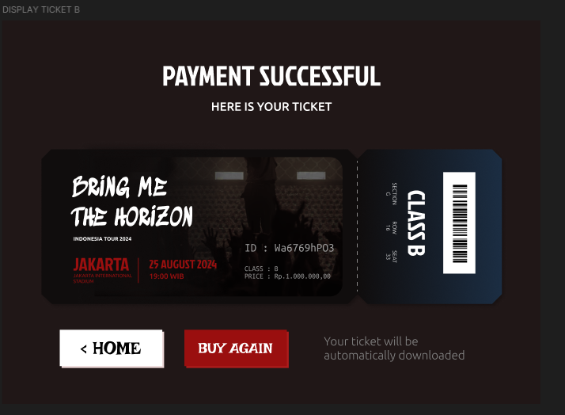

PAYMENT SUCCESSFUL (jockey one, 75px, white)

HERE IS YOUR TICKET (ubuntu medium, 32px white)

Button home = (h=97px, w=274px, irish groover black 48px)

Buy again = (h=97px, w=274px, irish groover white 40px)

Your ticket will be automatically downloaded ( ubuntu light, 32px, color : #858585)